专题五 介词

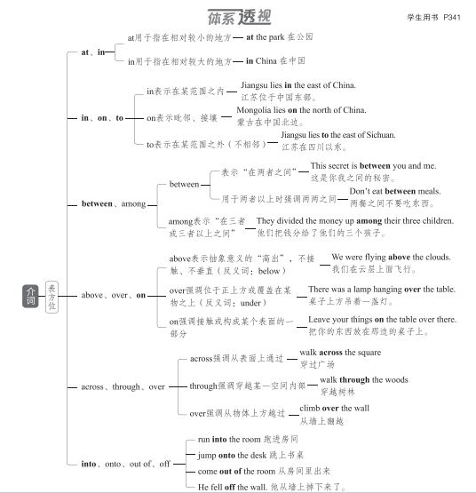

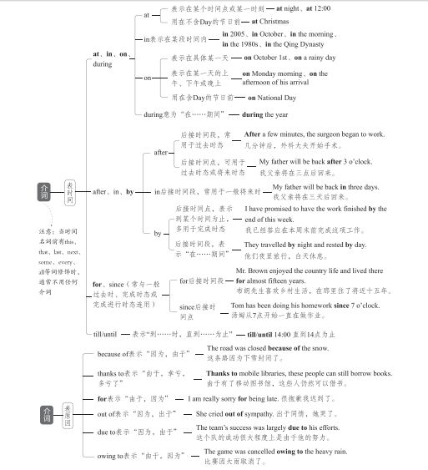

重难透析

常用介词的常考用法
 to 的用法
to与情感名词连用，表示“某种行动后产生的感 觉”。这种表达方法表示结果，用作状语，位于句子的 前、中、后皆可。为了强调，可在前面加 much, 意 为 “使某人非常……的是”。
to one's delight/surprise/horror/sorrow/joy/regret =
to the delight/surprise/horror/sorrow/joy/regret of sb.
使某人开心/惊讶/惊恐/难过/开心/遗憾的是
 with 的用法

用法 | 例句
表示“和……在一  起”“由……陪同”或 “有 … … 在场” | I have a client with me right now.  我现在有个客户。
表示两种事物之间  的相应关系或齐头 并进的意思 | With time passing,they have grown into big boys and big  girls.随着时间的流逝，他们长 成大男孩和大姑娘了。
表示“带有，带来，带 走，携带”等 | He looked at her with a hurt expression.他带着受伤害的神 情看着她。
用于构成with的复 合结构 | She sat back in the chair with  her eyes closed.她闭着眼睛舒 服地在椅子上坐着。
指原因或理由 | The small child trembled with fear.小孩吓得打哆嗦。
 by 的用法

用法 | 例句
表示触及或抓住 的人或物的部分 | He seized me by the arm. 他抓住我的胳膊。
用于计量 ， 表示 “以 … … 计” | Milk is sold by the pint,butter by the pound,and eggs by the dozen. 牛奶论品脱卖，黄油论磅卖，鸡蛋 论打卖。

续表

用法 | 例句
表示程度、数量 | This one is shorter than the other by three inches.  这个比那个短3英寸。
表示 “ 按照 ， 从 ……看” | By my watch,it is half past eleven. 按我的手表，现在是十一点半。
表示方式 ， 意为 “通过，凭借” | May I pay by credit card? 我能用信用卡付款吗?
表示 “ 靠近 ， 在 … … 旁边” | The telephone is by the window. 电话在窗户旁边。
用于被动语态，表 示施动者 | He was knocked down by a bus. 他被一辆公交车撞倒了。
beyond 的用法
用法 | 例句
表示“(时间)晚 于，迟于” | Don't stay out beyond midnight.  不要在外面待到午夜以后。
表示“(位置)在 (或向)……较远 的一边” | The small village is 20 miles beyond the town.  那个小村庄在城外20英里处。
表示“非……所能  及，超出……之 外 ” | This book is beyond me. 这本书我看不懂。  Her work is beyond praise.  她的工作令人赞不绝口。  Our success was far beyond what we thought possible.  我们的成功远远超出了我们的估 计范围。

常考介词搭配
介词+名词

类型 | 示例
at+n. | at ease 放松，不拘束 at present 现在 | at first首先  at random 随意 | at peace 和平  at risk 有危险，冒风险
by+n. | by accident/chance 偶然 by hand 用手 | by coincidence 纯属巧合 by mistake 错误地 | by design故意 by no means决不
in+n. | in advance 提前  in chaos 一片混乱 in debt 负债  in fact 事实上  in person 亲自  in reality 实际上  in summary 总之 | in brief 简言之  in common 共同  in demand 需求很大  in low spirits 情绪低落  in principle 原则上  in relief 放心地  in trouble 处于困境 | in cash 用现金  in danger 处于危险中  in detail 详细地  in particular 尤其，特别  in public 当众  in return 作为回报 in turn 轮流；转而
on+n. | on a(n)..basis 以……方式  on average 平均  on duty 值班 | on a diet 节食  on business 出差 on purpose 故意 | on a(n)..scale 以……规模  on occasion 偶尔  on sale 在售
with+n. | with ease 轻易，毫不费劲地 | with relief放心地 | with satisfaction满意地
prep.+n. +prep. | as a result of 由于  by means of 通过，借助于  in addition to 除……之外(还)  in comparison to/with 和……相比  in line with 与……一致  in possession of 拥有  in respect of 关于  in support of 支持  in the way of 关于  on one's/the way to 在……途中 | at the age of 在……岁时  for the honor of 为了……的荣誉  in case of 如果  in fear of 害怕  in need/want of 需要  in praise of 表扬  in search of 寻找  in terms of 就……而言 on account of 因为  on the basis of 以……为基础 | at the sight of 一看见  for the purpose of 为了  in charge of 负责  in honor/memory of 纪念 in place of 代替  in/with reference to 关于  in spite of 尽管  in the absence of 缺乏  on behalf of 代表  on top of 在……上面

  ②名词+ | 介词
类型 | 示例
n.+for | affection for 对……的喜爱  a preference for 对……的偏爱  the request for 对……的要求 | an excuse for……的理由 the need for 对……的需要 preparation(s)for 对……的准备 the reason for ……的原因  the respect for 对……的尊重 the talent for……的天赋
n.+from | absence from 缺席 | an escape from 从……逃离
n.+in | faith in 对……的信心 | progress in 在……方面的进步 success in 在……取得的成功
n.+of | lack of 缺乏
n.+on | the dependence on 对……的依赖 an impression on 给……的印象 | an effect/impact on 对……的影响

 | 续表
类型 | 示例
n.+to | the  the  the | access to 进入……的通道 attitude to 对……的态度 solution to…… 的解决办法 | the answer to ……的答案 the approach to ……的方法  the home to ……的家园  the key to ……的关键  the introduction to 对……的介绍
③ 动词+介词

类型 | 示例
v.+about | complain about 抱怨 talk about 谈论 | learn about 了解 think about 考虑 |  | set about 着手做 worry about 担心
v.+as | act as 充当 serve as 用作 |  |  | work as 从事……工作
v.+at | aim at 瞄准  laugh at 嘲笑 |  | glance at 瞥  shout/yell at 冲……嚷 | knock at 敲  stare at 盯着
v.+for | account for (数量上)占 long for 渴望  pay for 为…… ·付钱 search for 搜寻 |  | apply for 申请  look for 寻找  provide sth.for sb. 为某人提供某物 seek for 寻找 | ask for 要求  mistake...for.… 把……错当成…… run for 参加竞选  stand for 代表
v.+from | differ from 与……不同 result from 由……引起 | judge from 从……判断 separate from (使)分离 |  | learn from 向……学习  suffer from 遭受
v.+in | believe in 相信 result in 导致 |  | end in 以……告终 specialize in 专攻 | participate in 参加
v.+of | consist of由……组成 remind sb.of使某人想起 |  |  | speak of谈到
v.+on | call on 呼吁  depend/rely on 依赖 insist on 坚持 |  | carry on 继续  feed on 以……为食 reflect on 认真思考 | center/focus on 集中于  congratulate sb.on sth. 祝贺某人某事 remark on 对……发表评论
v.+to | admit to 承认  compare to 与……相比 | apologize to 向……道歉 devote to 致力于 |  | belong to 属于 lead to 导致  turn to 求助于
v.+to | refer to 指；谈到 |  | stick to 坚持 | belong to 属于 lead to 导致  turn to 求助于
v.+with | agree with 同意 argue with 与……争吵  communicate with 与……交流 compare with 与…… · 比较 provide sb.with sth. 为某人提供某物 |  |  | combine with 与……结合 deal with 处理  share with 与……分享

续表

类型 | 示例
v.+adv. +prep. | catch up with 追赶上  date/go back to 追溯到 get away from 远离  live up to 不辜负  miss out on 错失……机会 run out of 用完，耗尽  try out for 参加……选拔 | come down to 归结为  do away with 废除，取消 get down to 着手处理  look down on/upon 瞧不起 put up with 忍受  sign up for 报名参加 |  | come up with 想出  drop out of 退出  keep up with 与……保持联系 make up for 弥补  reach out to 向……伸出援手 think highly of 高度评价
v.+n.+prep. | catch sight of 看见  pay attention to 注意  take pride in 为……感到骄傲 make allowances for 考虑到 |  | give rise to 引起，导致 make fun of 取笑  take care of 照顾 take part in 参加  keep track of 了解……的动态；与……保持联系 turn one's back on 对……置之不理
v.+prep.  +n. | bring/put...into effect 实施  come to one's rescue 前来营救 |  | come into being/existence 出现，存在  keep..in mind 把……记在心上 put...into practice 把……付诸实践


④形容词+介词

类型 | 示例
adj.+about | be curious about 对……好奇  be serious about 对……严肃对待 |  |  |  | be enthusiastic about 对……热情  be worried about 对……担忧
adj.+at | be amazed/astonished/shocked at 对……感到吃惊 be bad/good at 不擅长/擅长
adj.+from | be different from与……不同 be free from 不受……影响 be safe from免于
adj.+for | be bad for 对……有害  be fit for 适合  be responsible for 对……负责 |  |  | be convenient for 对……方便  be hungry for 渴望  be thankful for 因……而感激 |  |  | be eager for 渴望  be ready for 为……做好准备
adj.+in | be absorbed  be/get lost | in 专心于  in 沉迷于 |  | be dressed in穿着  be rich in富含 |  |  | be experienced in 对……有经验  be weak in 不擅长
adj.+of | be ashamed of 对……感到羞耻  be proud of 对……感到骄傲  be tired of 厌倦 |  |  | be aware of 意识到 be short of 缺乏  be worthy of 值得 |  |  | be  be | free of 免于  sick of 厌烦
adj.+on | be dependent on 取决于 be keen on喜欢，热衷于
adj.+to | be addicted to 对……上瘾  be equal to 等于  be similar to 与……相似 |  | be accustomed to 习惯于  be harmful to 对……有害  be unfamiliar to 对……不熟悉 |  |  | be contrary to 与……相反 be/get married to 嫁给
adj.+with | be content with 对……满足  be filled with 充满  be popular with 受……欢迎 |  | be crowded with 挤满  be occupied with 忙于  be strict with 对……严格 |  |  | be familiar with 对……熟悉  be patient with对……有耐心

考点针对练
1. The UN Chinese Language Day not only provides a unique platform the world to better understand China,but also promotes language and cultural exchanges in the world.
2. As a special education teacher at the school,I was familiar the challenges David faced and was proud of his strong determination.
3. There, you'll find them prepared differently — more dumpling and less soup — and the wrappers are pressed hand rather than rolled.
4. And who do they speak English ? Not the pandas,even though the language used for the medical training instructions is actually English.
5. A new secretary will be hired to relieve us some of the paperwork.
6. She warns of the environmental dangers facing society, and she teaches that people must take responsibility saving their environment.
7. Giant pandas also serve an umbrella species, bringing protection to a host of plants and animals in the
southwestern and northwestern parts of China.
8. Since April drinks companies have been forced to pay between 18p and 24p for every litre of sugary drink they produce or import,depending the sugar content.
9. He flew 4,700 kilometers Xi'an to Kashgar on Sept.20, planning to hike back to Xi'an in five months.
10. Put the medicine children's reach in case it's taken by mistake.
11. Due to the growing popularity of environmentally-related and adventure travel, various types trips are now being classified as ecotourism.
12. After careful consideration,he chose to withdraw the competition.
13. I happen to know that Tang’s play The Peony Pavilion (《牡丹亭》) is similar in some ways Romeo and Juliet.
14. The artist was finally humbled(谦卑) by the greatest artist earth, Mother Nature.
15. Some time after 10,000 BC, people made the first real attempt to control the world they lived through agriculture.
16. This aging of the population is driven two factors.
17. This level of preservation could not be achieved the participation of generations of local residents.
18. But can uniforms help improve school standards? The answer this question is not clear.

